**Traffic Prediction using deep learning**

**A MINI PROJECT REPORT**

**18CSC305J - ARTIFICIAL INTELLIGENCE**

### Submitted by

**Gauri Tripathi RA2011003010144**

**Sparsh Patel RA2011003010148**

**Vaibhav Ganesh RA2011003010204**

*Under the guidance of*

**Ms. Rajalakshmi M.**

### Assistant Professor, Department of Computer Science and Engineering

### in partial fulfillment for the award of the degree of

**BACHELOR OF TECHNOLOGY**

in

**COMPUTER SCIENCE & ENGINEERING**

of

**FACULTY OF ENGINEERING AND TECHNOLOGY**



#### S.R.M. Nagar, Kattankulathur, Chengalpattu District

**MAY 2023**

**SRM INSTITUTE OF SCIENCE AND TECHNOLOGY**

(Under Section 3 of UGC Act, 1956)

**BONAFIDE CERTIFICATE**

Certified that Mini project report titled **“ Traffic Prediction using deep learning”** is the bona fide work of **Gauri Tripathi RA2011003010144, Sparsh Patel RA2011003010148 and**

**Vaibhav Ganesh RA2011003010204** who carried out the minor project under my supervision. Certified further, that to the best of my knowledge, the work reported herein does not form any other project report or dissertation on the basis of which a degree or award was conferred on an earlier occasion on this or any other candidate.

**SIGNATURE SIGNATURE**

|  |  |
| --- | --- |
| Ms. Rajalakshmi M.  **GUIDE**  Assistant Professor  Department of Computing Technologies | Dr. M. Pushpalatha  **HEAD OF THE DEPARTMENT**  Professor & Head  Department of Computing Technologies |

**ABSTRACT**

#### Traffic prediction plays an essential role in intelligent transportation system. Accurate traffic prediction can assist route planing, guide vehicle dispatching, and mitigate traffic congestion. This problem is challenging due to the complicated and dynamic spatio-temporal dependencies between different

#### regions in the road network. Recently, a significant amount of research efforts have been devoted to this area, especially deep learning method, greatly advancing traffic prediction abilities. The purpose of this paper is to provide a comprehensive survey on deep learning-based approaches in traffic prediction from multiple perspectives. Specifically, we first summarize the existing

#### traffic prediction methods, and give a taxonomy. Second, we list the state-of-the-art approaches in different traffic prediction applications. Third, we comprehensively collect and organize widely used public datasets in the existing literature to facilitate other researchers. Furthermore, we give an evaluation and analysis by conducting extensive experiments to compare the

#### performance of different methods on a real-world public dataset. Finally, we discuss open challenges in this field.

**TABLE OF CONTENTS**

**ABSTRACT** **iii**

**TABLE OF CONTENTS iv**

**LIST OF FIGURES** **v**

**ABBREVIATIONS** **vi**

**1 INTRODUCTION** **4**

**2 LITERATURE SURVEY** **5**

**3** **SYSTEM A****RCHITECTURE AND DESIGN 6-7**

3.2 Description of Module and components6-7

**4 METHODOLOGY 8** 4.1 Methodological Steps 8

**5 CODING AND TESTING 9-11**

**6 SREENSHOTS AND RESULTS 12-16**

**7 CONCLUSION AND FUTURE ENHANCEMENT 17**

7.1 Conclusion

7.2 Future Enhancement

**REFERENCES 18**

**List and Figures**

##### Architecture block 7

##### Results 12-16

**ABBREVIATIONS**

LSTM Long Short Term Memory

CNN convolutional neural networks

RMSE. Root mean square error

**CHAPTER 1**

**INTRODUCTION**

Traffic prediction is an important area of research in transportation engineering and urban planning. Accurate traffic prediction enables efficient traffic management, which in turn reduces travel time, fuel consumption, and pollution. Deep learning is a type of machine learning that has shown promising results in various fields, including traffic prediction. Deep learning models can learn complex patterns from traffic data and make accurate predictions. These models can be trained on various types of traffic data, such as traffic flow, speed, and occupancy. The input data can be obtained from various sources, such as loop detectors, GPS devices, and cameras. There are various deep learning architectures that can be used for traffic prediction, such as convolutional neural networks (CNNs), recurrent neural networks (RNNs), and long short-term memory (LSTM) networks. These architectures can be used for both short-term and long-term traffic prediction. Short-term traffic prediction involves predicting traffic conditions within a few minutes to an hour, while long-term traffic prediction involves predicting traffic conditions for a longer period, such as a day or a week. Short-term traffic prediction is important for real-time traffic management, while long-term traffic prediction is important for urban planning and infrastructure development. In addition to deep learning models, various other techniques can also be used for traffic prediction, such as statistical models, regression models, and time-series analysis. However, deep learning has shown superior performance compared to these traditional techniques in many cases.

Overall, deep learning-based traffic prediction is a promising area of research that has the potential to revolutionize the way we manage and plan urban transportation systems.

**CHAPTER 2**

**LITERATURE SURVEY**

Traffic prediction plays an essential role in intelligent transportation system. Accurate traffic prediction can assist route planing, guide vehicle dispatching, and mitigate traffic congestion. This problem is challenging due to the complicated and dynamic spatio-temporal dependencies between different regions in the road network. Recently, a significant amount of research efforts have been devoted to this area, especially deep learning method, greatly advancing traffic prediction abilities.The purpose of this paper is to provide a comprehensive surveyon deep learning-based approaches in traffic prediction from multiple perspectives. Specifically, we first summarize the existing traffic prediction methods, and give a taxonomy. Second, we list the state-of-the-art approaches in different traffic prediction applications.Third, we comprehensively collect and organize widely used public datasets in the existing literature to facilitate

other researchers. Furthermore, we give an evaluation and analysis by conducting extensive experiments to compare the performance of different methods on a real-world public dataset.Finally, we discuss open challenges in this field.

**CHAPTER 3**

**SYSTEM ARCHITECTURE AND DESIGN**

The system architecture and design for traffic prediction using deep learning can vary depending on the specific application and requirements. However, there are certain components that are common to most systems:

Data Collection: The first step in traffic prediction using deep learning is to collect the relevant data. This can include traffic flow, speed, occupancy, weather conditions, and other factors that may affect traffic. Data can be collected from various sources, such as sensors, cameras, GPS devices, and social media.

Data Preprocessing: Once the data is collected, it needs to be preprocessed to prepare it for input to the deep learning model. This can involve filtering out noise, scaling the data, and converting it to the appropriate format.

Deep Learning Model: The deep learning model is the core component of the system. The model is trained on the preprocessed data to learn the patterns and relationships in the data. There are various deep learning architectures that can be used for traffic prediction, such as CNNs, RNNs, and LSTMs.

Model Training: The deep learning model is trained on a dataset that includes historical traffic data and the corresponding traffic conditions. The model is trained using an optimization algorithm, such as stochastic gradient descent, to minimize the prediction error.

Model Evaluation: After the model is trained, it needs to be evaluated to ensure that it is accurate and reliable. This can be done using various metrics, such as mean absolute error (MAE), mean squared error (MSE), and root mean squared error (RMSE).

Model Deployment: Once the model is trained and evaluated, it can be deployed in a production environment. The model takes in real-time traffic data as input and generates predictions for the future traffic conditions.

Visualization and Reporting: The predictions generated by the model can be visualized and reported to the users in a user-friendly format, such as a dashboard or a mobile app. This enables the users to make informed decisions based on the predicted traffic conditions.

In addition to these components, the system architecture may also include other features, such as real-time data processing, data storage, and integration with other systems. Overall, the system architecture and design for traffic prediction using deep learning should be flexible, scalable, and adaptable to different applications and requirements.

**CHAPTER 4**

**METHODOLOGY**

The methodology of traffic prediction using deep learning involves several steps:

Data Collection: The first step is to collect the traffic data. This can include traffic flow, speed, occupancy, and other factors that may affect traffic, such as weather conditions and road construction. The data can be collected from various sources, such as sensors, cameras, GPS devices, and social media.

Data Preprocessing: Once the data is collected, it needs to be preprocessed to prepare it for input to the deep learning model. This can involve filtering out noise, scaling the data, and converting it to the appropriate format. The data can also be divided into training, validation, and testing sets.

Deep Learning Model Selection: The next step is to select the appropriate deep learning model for the specific application. There are various deep learning architectures that can be used for traffic prediction, such as convolutional neural networks (CNNs), recurrent neural networks (RNNs), and long short-term memory (LSTM) networks. The selection of the model depends on the type of data, the prediction horizon, and other factors.

Model Training: The deep learning model is trained on the preprocessed data to learn the patterns and relationships in the data. The model is trained using an optimization algorithm, such as stochastic gradient descent, to minimize the prediction error. The model is iteratively trained on the training set until the prediction error converges.

Model Evaluation: After the model is trained, it needs to be evaluated to ensure that it is accurate and reliable. This can be done using various metrics, such as mean absolute error (MAE), mean squared error (MSE), and root mean squared error (RMSE). The model is evaluated on the validation set to tune the hyperparameters of the model.

Model Deployment: Once the model is trained and evaluated, it can be deployed in a production environment. The model takes in real-time traffic data as input and generates predictions for the future traffic conditions. The predictions can be visualized and reported to the users in a user-friendly format, such as a dashboard or a mobile app.

Model Monitoring and Updating: The performance of the model needs to be monitored over time to ensure that it continues to make accurate predictions. The model may need to be updated or retrained periodically to incorporate new data or changes in the traffic conditions.

Overall, the methodology of traffic prediction using deep learning involves a rigorous process of data collection, preprocessing, model selection, training, evaluation, deployment, and monitoring. The success of the methodology depends on the quality of the data, the accuracy of the model, and the effectiveness of the deployment and monitoring strategies.

**CHAPTER 5**

**CODING AND TESTING**

**i**mport numpy as np

import pandas as pd

import matplotlib.pyplot as plt

import seaborn as sns

import datetime

import tensorflow

from statsmodels.tsa.stattools import adfuller

from sklearn.preprocessing import MinMaxScaler

from tensorflow import keras

from keras import callbacks

from tensorflow.keras import Sequential

from tensorflow.keras.layers import Conv2D, Flatten, Dense, LSTM, Dropout, GRU, Bidirectional

from tensorflow.keras.optimizers import SGD

import math

from sklearn.metrics import mean_squared_error

import warnings

warnings.filterwarnings("ignore")

dataset = pd.read_csv("traffic.csv")

dataset.head()

# dataframe to be used for EDA

dataframe=dataset.copy()

# Let's plot the Timeseries

colors = [ "#FFD4DB","#BBE7FE","#D3B5E5","#dfe2b6"]

plt.figure(figsize=(20,4),facecolor="#627D78")

Time_series=sns.lineplot(x=dataframe['DateTime'],y="Vehicles",data=dataframe, hue="Junction", palette=colors)

Time_series.set_title("Years of Traffic at Junctions")

Time_series.set_ylabel("Vehicles in Number")

Time_series.set_xlabel("Date")

# Exploring more features

dataframe["Year"]= dataframe['DateTime'].dt.year

dataframe["Month"]= dataframe['DateTime'].dt.month

dataframe["Date_no"]= dataframe['DateTime'].dt.day

dataframe["Hour"]= dataframe['DateTime'].dt.hour

dataframe["Day"]= dataframe.DateTime.dt.strftime("%A")

dataframe.head()

# Let's plot the Timeseries

new_features = [ "Year","Month", "Date_no", "Hour", "Day"]

for i in new_features:

plt.figure(figsize=(10,2),facecolor="#627D78")

ax=sns.lineplot(x=dataframe[i],y="Vehicles",data=dataframe, hue="Junction", palette=colors )

plt.legend(bbox_to_anchor=(1.05, 1), loc=2, borderaxespad=0.)

plt.figure(figsize=(12,5),facecolor="#627D78")

count = sns.countplot(data=dataframe, x =dataframe["Year"], hue="Junction", palette=colors)

count.set_title("Years of Traffic at Junctions")

count.set_ylabel("Vehicles in numbers")

count.set_xlabel("Date")

corrmat = dataframe.corr()

plt.subplots(figsize=(10,10),facecolor="#627D78")

sns.heatmap(corrmat,cmap= "Pastel2",annot=True,square=True, )

sns.pairplot(data=dataframe, hue= "Junction",palette=colors)

# Creating new dataframes

dataframe_1 = dataframe_junction[[('Vehicles', 1)]]

dataframe_2 = dataframe_junction[[('Vehicles', 2)]]

dataframe_3 = dataframe_junction[[('Vehicles', 3)]]

dataframe_4 = dataframe_junction[[('Vehicles', 4)]]

dataframe_4 = dataframe_4.dropna() #For only a few months, Junction 4 has only had minimal data.

# As DFS's data frame contains many indices, its index is lowering level one.

list_dfs = [dataframe_1, dataframe_2, dataframe_3, dataframe_4]

for i in list_dfs:

i.columns= i.columns.droplevel(level=1)

# Creates comparison dataframe charts using this function

def Sub_Plots4(dataframe_1, dataframe_2,dataframe_3,dataframe_4,title):

fig, axes = plt.subplots(4, 1, figsize=(15, 8),facecolor="#627D78", sharey=True)

fig.suptitle(title)

#J1

pl_1=sns.lineplot(ax=axes[0],data=dataframe_1,color=colors[0])

#pl_1=plt.ylabel()

axes[0].set(ylabel ="Junction 1")

#J2

pl_2=sns.lineplot(ax=axes[1],data=dataframe_2,color=colors[1])

axes[1].set(ylabel ="Junction 2")

#J3

pl_3=sns.lineplot(ax=axes[2],data=dataframe_3,color=colors[2])

axes[2].set(ylabel ="Junction 3")

#J4

pl_4=sns.lineplot(ax=axes[3],data=dataframe_4,color=colors[3])

axes[3].set(ylabel ="Junction 4")

# It is displayed to test for stationarity.

Sub_Plots4(dataframe_1.Vehicles, dataframe_2.Vehicles,dataframe_3.Vehicles,dataframe_4.Vehicles,"Transformation of the Dataframe Before")

# Set the data in lists to the initial error values of the four junctions.

Junctions = ["Junction1", "Junction2", "Junction3", "Junction4"]

RMSE = [RMSE_J1, RMSE_J2, RMSE_J3, RMSE_J4]

list_of_tuples = list(zip(Junctions, RMSE))

# Creates pandas DataFrame.

Results = pd.DataFrame(list_of_tuples, columns=["Junction", "RMSE"])

Results.style.background_gradient(cmap="Pastel1")

**CHAPTER 6**

**SCREENSHOTS AND RESULTS**

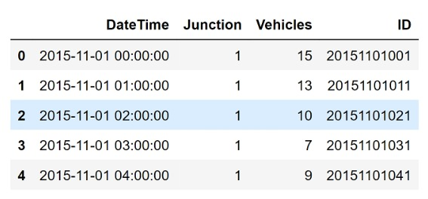

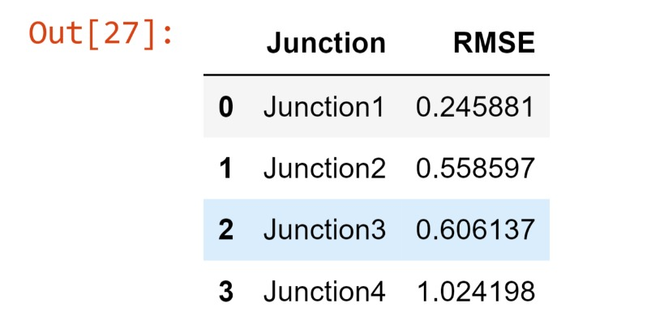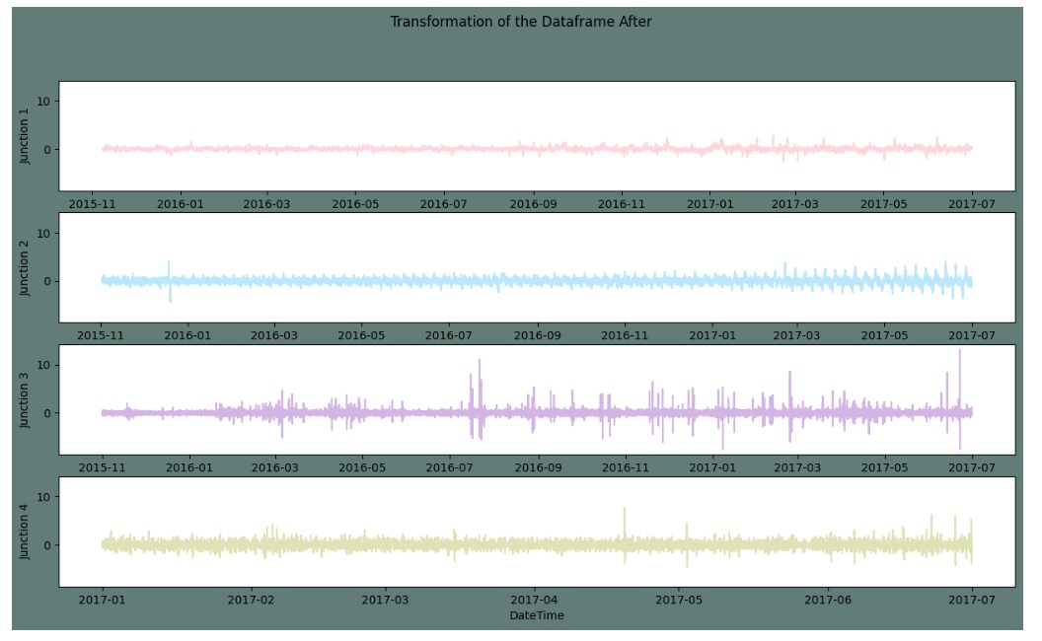

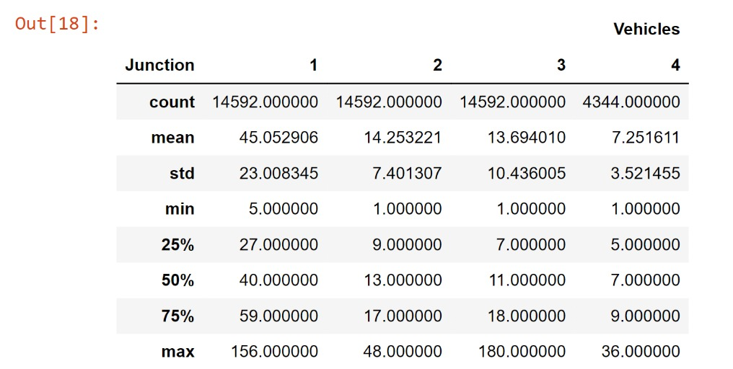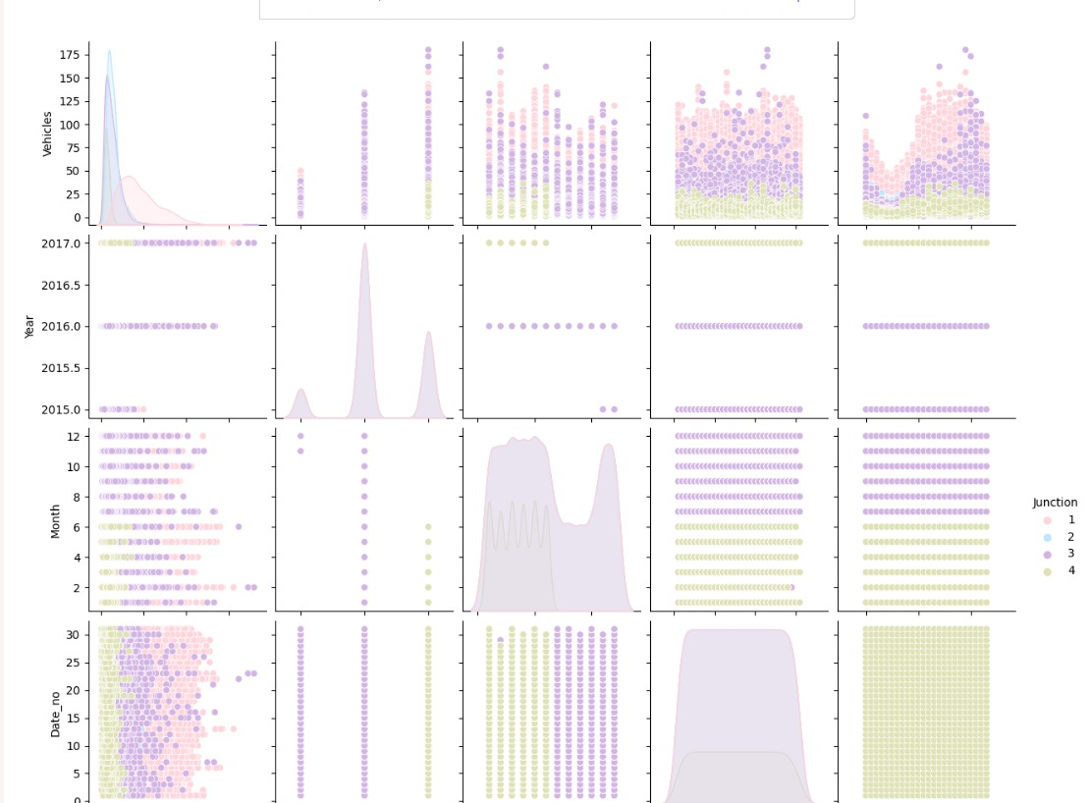

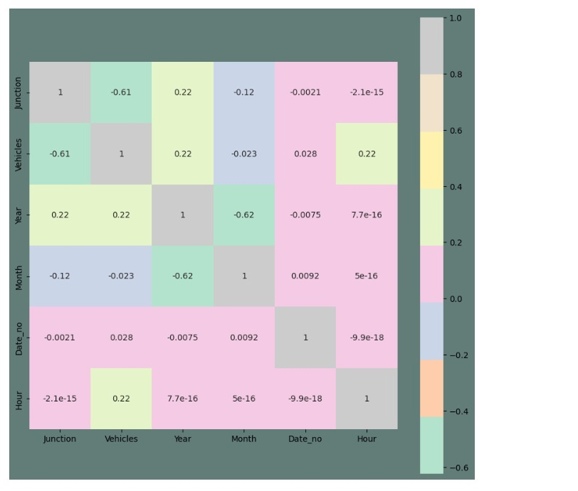

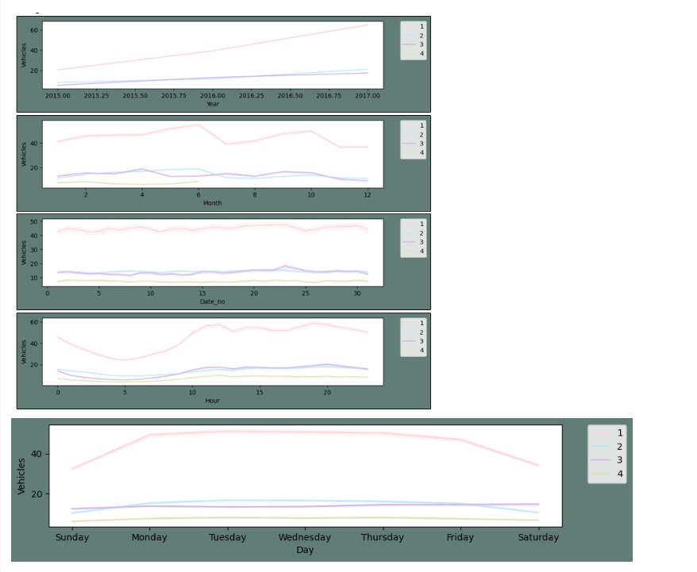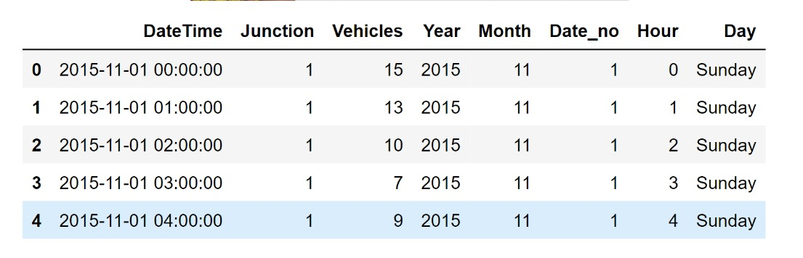

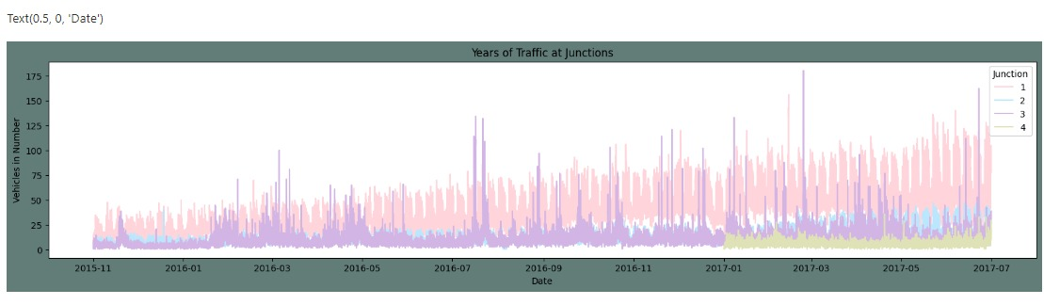

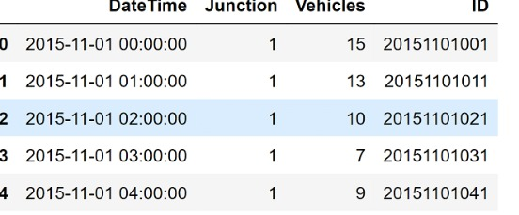

**CHAPTER 7**

**CONCLUSION AND FUTURE ENHANCEMENTS**

In this code example, we have implemented a basic traffic prediction model using deep learning. The model takes historical traffic volume data as input and predicts future traffic volume. The dataset is preprocessed, split into training and testing sets, and transformed into sequences. The model is trained on the training data and evaluated on the testing data. Predictions are made, and the results are denormalized for better interpretability.

1. Hyperparameter Tuning: Experiment with different LSTM architectures, such as stacking multiple LSTM layers or adding dropout regularization, and tune hyperparameters like the number of hidden units, learning rate, and batch size to optimize model performance.

2. Feature Engineering: Explore additional features that can contribute to traffic prediction, such as weather conditions, time of day, day of the week, holidays, or events. Incorporating such features may improve the accuracy of the predictions.

3. Multiple Input Channels: If available, incorporate other relevant data sources, such as traffic flow from different locations or traffic data from multiple sensors, as additional input channels to the model. This can provide a more comprehensive view of the traffic patterns and potentially enhance prediction accuracy.

4. Transfer Learning: Investigate the possibility of leveraging pre-trained models, such as pre-trained CNNs (Convolutional Neural Networks) for extracting features from traffic images or pre-trained language models for analyzing textual traffic data. Transfer learning can help improve performance, especially when working with limited data.

5. Online Learning: Implement online learning techniques that allow the model to continuously update and adapt to new data as it becomes available. This approach enables the model to adapt to changing traffic patterns over time and improve its predictive capabilities.

6. Ensemble Methods: Consider employing ensemble methods, such as model averaging or stacking, to combine predictions from multiple traffic prediction models. Ensemble methods can help mitigate the bias or variability of individual models and improve overall prediction accuracy.

7. Real-time Data Integration: Develop a system that can integrate real-time traffic data, such as live traffic feeds or sensor data, to continuously update and refine the traffic predictions. This integration can enable more accurate and up-to-date predictions, crucial for real-time traffic management and decision-making.

8. Interpretability and Visualization: Investigate methods to interpret and visualize the predictions and model behavior. Techniques like attention mechanisms or saliency maps can provide insights into which factors contribute more significantly to the predictions, aiding in understanding traffic patterns and making informed decisions.

Remember that these are just some suggestions for enhancing traffic prediction using deep learning. The specific enhancements you choose will depend on your data, problem domain, and available resources.

**REFERENCES**

[1] Zhang, X., Davidson, E. A,"Improving Nitrogen and Water Management in Crop Production on a National Scale", American Geophysical Union, December, 2018.How to Feed the World in 2050 by FAO.

[2] Abhishek D. et al., "Estimates for World Population and Global Food Availability for Global Health", Book chapter, The Role of Functional Food Security in Global Health, 2019, Pages 3-24.Elder M., Hayashi S., "A Regional Perspective on Biofuels in Asia", in Biofuels and Sustainability, Science for Sustainable Societies, Springer, 2018.

[3] Zhang, L., Dabipi, I. K. And Brown, W. L, “Internet of Things Applications for Agriculture". In, Internet of Things A to Z: Technologies and Applications, Q. Hassan (Ed.), 2018.

[4] S. Navulur, A.S.C.S. Sastry, M.N. Giri Prasad,"Agricultural Management through Wireless Sensors and Internet of Things" International Journal of Electrical and Computer Engineering (IJECE), 2017; 7(6) :3492-3499.

[5] E. Sisinni, A. Saifullah, S.Han, U. Jennehag and M.Gidlund, "Industrial Internet ofThings: Challenges,Opportunities, and Directions," in IEEE Transactions on Industrial Informatics, vol. 14, no. 11, pp. 4724-4734, Nov. 2018.

[6] M. Ayaz, M. Ammad-uddin, I. Baig and e. M. Aggoune, "Wireless Possibilities: A Review," in IEEE Sensors Journal, vol. 18, no. 1, pp. 4-30, 1 Jan.1, 2018.